GPU and Cooling Systems

- Introduction
The Graphics Processing Unit (GPU) is one of the most important components in a modern computer system. It is responsible for processing and rendering images, videos, animations, and graphical data. GPUs are widely used in gaming, video editing, 3D modeling, artificial intelligence, and streaming applications. As GPUs perform millions of calculations every second, they generate a significant amount of heat. To ensure stable performance and prevent damage from overheating, computers use cooling systems such as air cooling and liquid cooling. This assignment explores GPU identification, cooling components, and compares different cooling methods used in modern PCs.
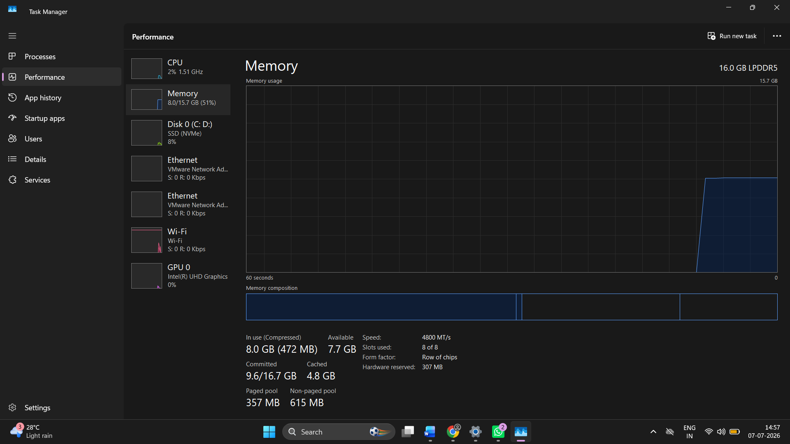

1. GPU Identification
System Used: Lenovo IdeaPad Slim 3 15IAH8
GPU Brand: Intel
GPU Model: Intel UHD Graphics
GPU Type: Integrated Graphics Processing Unit
Key Features and Functions
- Built-in Graphics Solution
  - Intel UHD Graphics is integrated directly into the Intel Core i5-12450H processor.
  - It does not require a separate graphics card.
- Shared Memory Usage
  - Unlike dedicated GPUs, it does not have its own video memory (VRAM).
  - It uses a portion of the system's RAM for graphics processing.
- Power Efficient
  - Consumes less power compared to dedicated graphics cards.
  - Helps improve battery life in laptops.
- Lower Heat Generation
  - Produces less heat during operation.
  - Requires a simpler cooling system, making laptops thinner and lighter.
- Suitable for Everyday Tasks
  - Web browsing and internet usage.
  - Watching HD and Full HD videos.
  - Online classes and video conferencing.
  - Microsoft Office applications (Word, Excel, PowerPoint).
  - Multimedia and entertainment purposes.
- Light Gaming Support
  - Can run older and less demanding games smoothly.
  - Suitable for casual gaming and esports titles at lower settings.
- Cost Effective
  - Reduces the overall cost of the laptop since no separate graphics card is required.
  - Makes the system more affordable for students and office users.
- Limitations
  - Not designed for high-end gaming.
  - Less suitable for 3D rendering, advanced video editing, and professional graphics work.
  - Performance is lower than dedicated GPUs such as NVIDIA GeForce or AMD Radeon graphics cards.
Conclusion
Intel UHD Graphics is an integrated GPU that provides reliable performance for daily computing activities while maintaining low power consumption and efficient operation. It is an excellent choice for students, office workers, and general users who need a balance of performance, battery life, and affordability.

2. Cooling System Identification
Introduction
A cooling system is an essential part of every computer because it helps maintain safe operating temperatures for critical hardware components such as the CPU and GPU. During tasks like gaming, video editing, streaming, or multitasking, these components generate a significant amount of heat. If this heat is not removed efficiently, the system may overheat, resulting in reduced performance, unexpected shutdowns, or even permanent hardware damage. To prevent this, computers use cooling solutions such as fans, heatsinks, heat pipes, and liquid cooling systems.
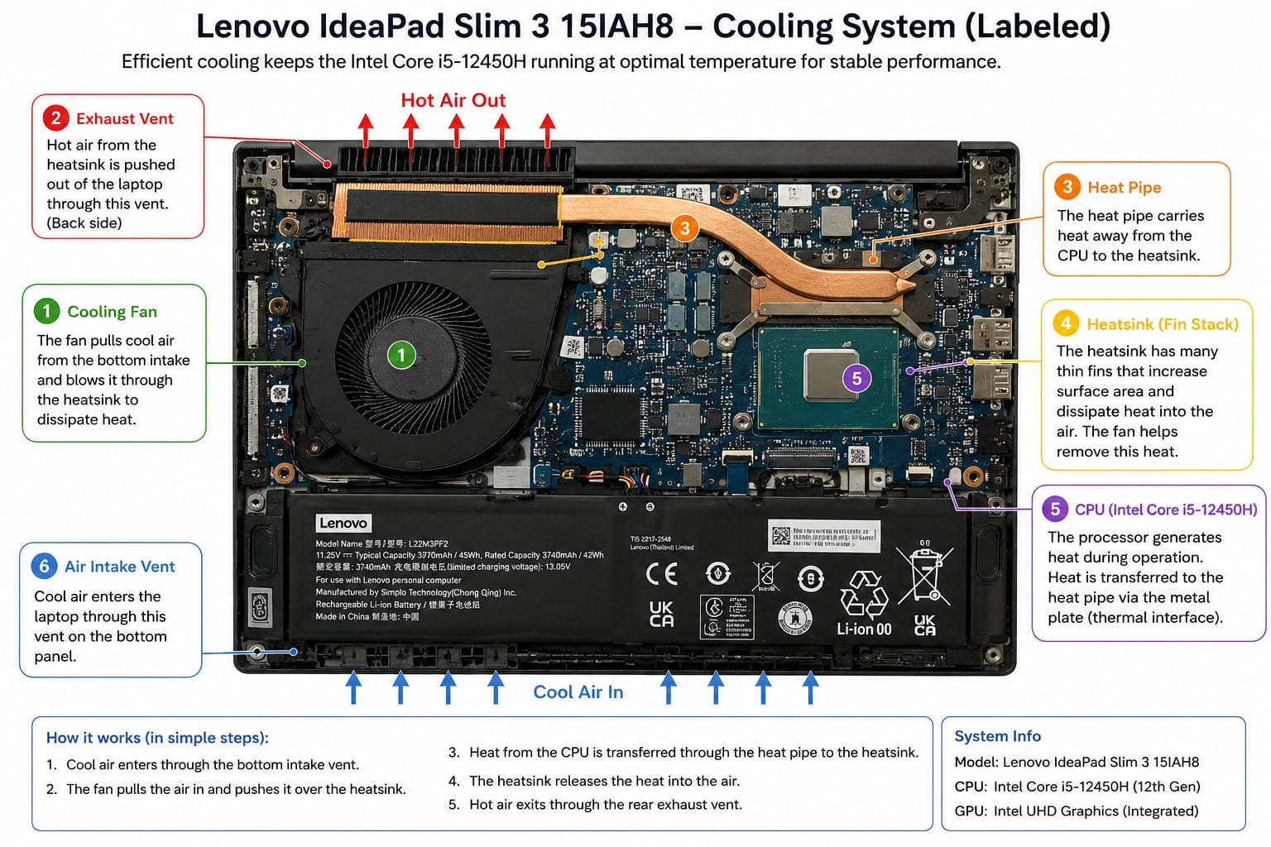

Main Cooling Components and Their Functions
Component | Function
Cooling Fan | Draws cool air into the system and expels hot air, maintaining airflow and reducing component temperatures.
Heatsink | Absorbs heat from the CPU or GPU and transfers it to the surrounding air through metal fins.
Heat Pipes | Transport heat from the processor to the heatsink quickly and efficiently.
Air Vents | Allow cool air to enter and hot air to leave the computer system.
Radiator (Liquid Cooling Systems) | Dissipates heat from the liquid coolant into the surrounding air.
Pump (Liquid Cooling Systems) | Circulates coolant throughout the cooling loop.
Coolant Tubes (Liquid Cooling Systems) | Carry coolant between the water block, pump, and radiator.

3. Comparison Between Air Cooling and Liquid Cooling
Introduction
Graphics Processing Units (GPUs) generate a significant amount of heat, especially during gaming, video editing, 3D rendering, and other graphics-intensive tasks. To maintain optimal performance and prevent overheating, GPUs require an effective cooling system. The two most common cooling methods are Air Cooling and Liquid Cooling. While both are designed to remove heat from the GPU, they differ in terms of cooling efficiency, cost, maintenance requirements, noise levels, and installation complexity.

Comparison Table: Air Cooling vs Liquid Cooling
Feature | Air Cooling | Liquid Cooling
Cooling Method | Uses fans and heatsinks to dissipate heat. | Uses liquid coolant, pump, tubing, and radiator to transfer heat.
Cost | More affordable and budget-friendly. | More expensive due to additional components.
Cooling Efficiency | Provides good cooling for most gaming and everyday systems. | Offers superior cooling performance, especially under heavy workloads.
Installation | Simple and easy to install. | More complex installation process.
Maintenance | Requires very little maintenance. | Requires periodic inspection and maintenance.
Noise Level | Fans may become noisy at high speeds. | Generally quieter because heat is distributed more efficiently.
Space Requirement | Takes less space and fits in most PC cases. | Requires additional space for radiators and tubing.
Reliability | Highly reliable with fewer components. | More components increase the possibility of failure or leaks.
Best Use Case | Everyday gaming, office work, and general-purpose PCs. | High-end gaming, overclocking, and professional workstations.

4. Recommended Cooling Solution for a Gaming and Streaming PC
Scenario
Imagine that I am building a gaming PC for two main purposes:
- Streaming IPL matches in high quality.
- Playing graphics-intensive games such as GTA V, Cyberpunk 2077, Call of Duty: Warzone, Red Dead Redemption 2, and Forza Horizon 5.
These activities place a heavy workload on the GPU, causing it to generate a large amount of heat. Therefore, selecting an efficient cooling solution is important for maintaining performance and system stability.

My Choice: Liquid Cooling
I would choose liquid cooling for the GPU because it provides superior cooling performance compared to traditional air cooling. During long gaming sessions and continuous streaming, the GPU operates under heavy load and generates significant heat. Liquid cooling can remove heat more efficiently, helping maintain lower temperatures and preventing performance loss caused by overheating.
Another reason for choosing liquid cooling is its ability to maintain stable performance during demanding tasks. Lower GPU temperatures allow the graphics card to sustain higher clock speeds for longer periods, resulting in smoother gameplay and a better streaming experience. This is especially beneficial when running multiple applications simultaneously, such as a game, streaming software, voice chat, and a web browser.
Liquid cooling systems are also generally quieter than air-cooling systems because they rely less on high-speed fans. Reduced noise levels create a more comfortable environment for gaming, streaming, and recording content. Although liquid cooling is more expensive and requires more maintenance than air cooling, the improved thermal performance, lower noise levels, and enhanced system stability make it an excellent choice for a high-end gaming and streaming PC.

Conclusion
The GPU is responsible for rendering graphics and enhancing the visual experience of a computer system. In this assignment, the identified GPU was Intel UHD Graphics, an integrated graphics solution suitable for everyday computing tasks. The study of cooling systems demonstrated the importance of fans, heatsinks, heat pipes, and airflow in maintaining safe temperatures. A comparison of air cooling and liquid cooling highlighted the strengths and limitations of each approach. Based on the research, air cooling remains an excellent choice for most gaming and streaming systems due to its reliability, affordability, and ease of maintenance.

